Waseem Khan Dawar




Maven

Practice


Create EC2 Instance

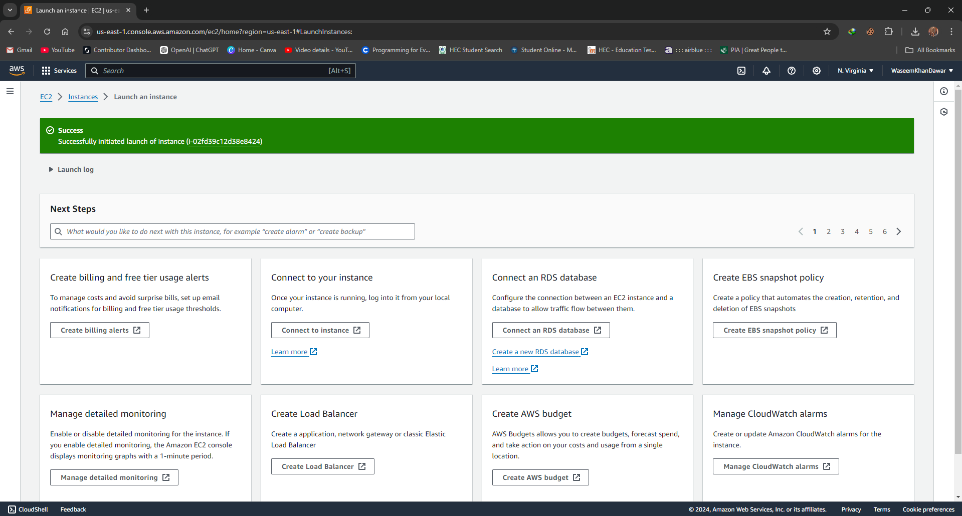


Optional: Open Created EC2 Instance in Local MobaXterm

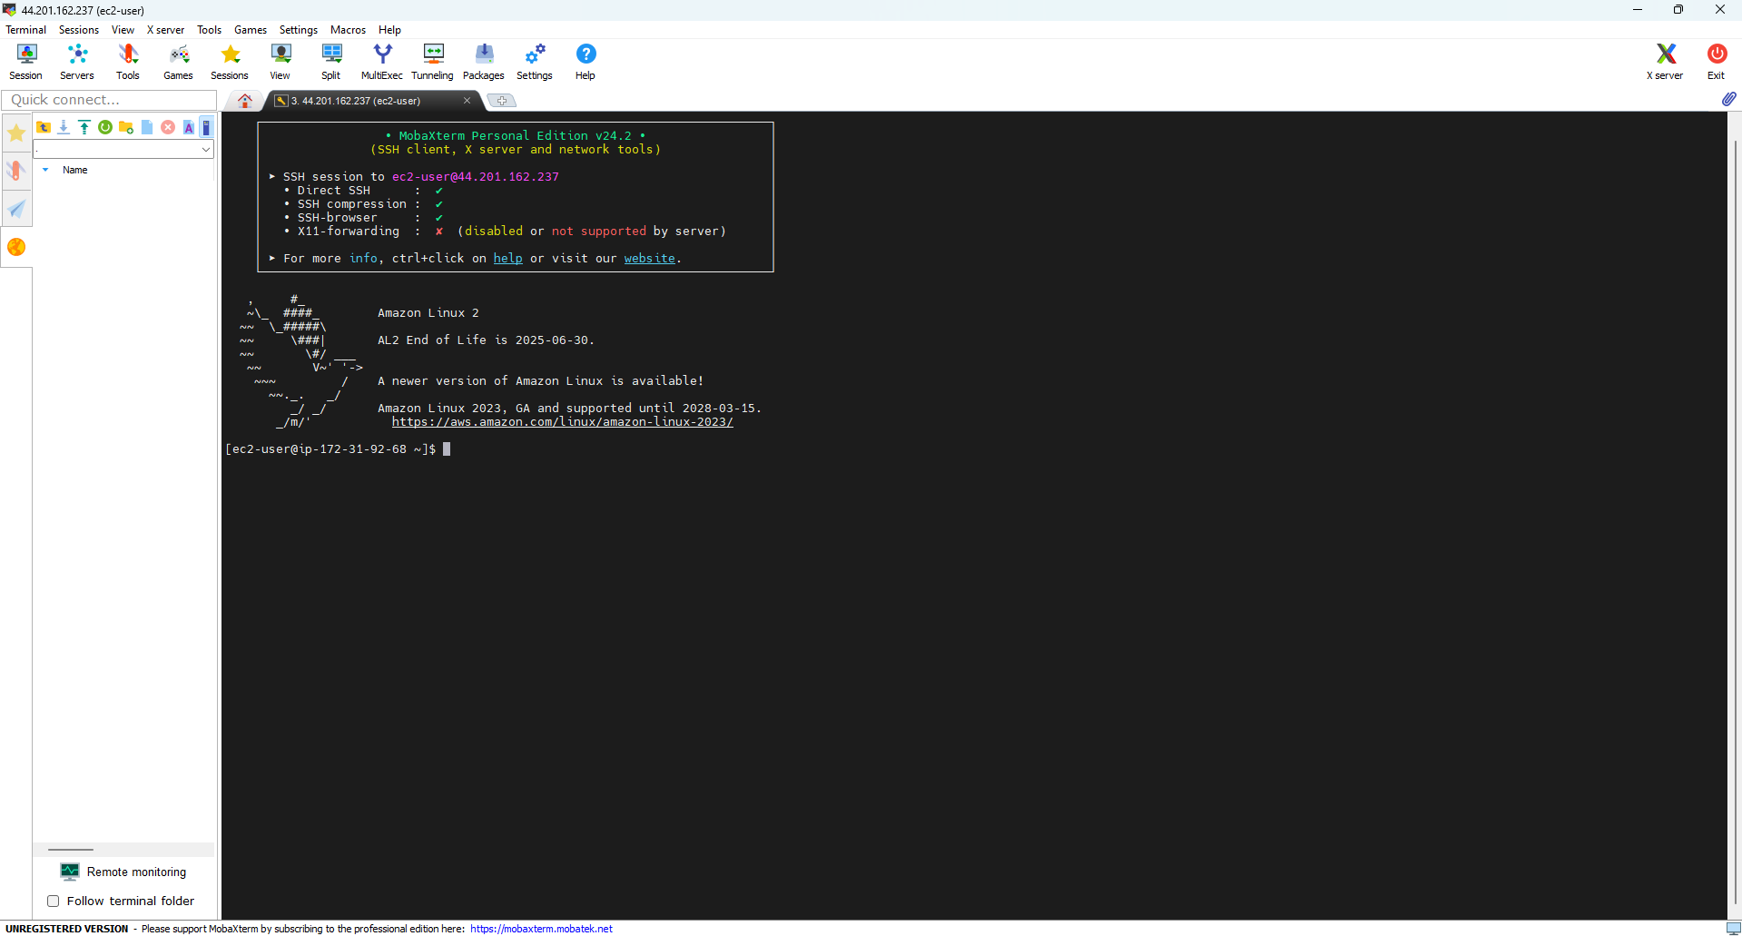

In

stall Maven if not installed by using the below command
- yum install git java-1.8.0-openjdk maven -y

Note: Above command will be installing 3 packages git, java and maven.

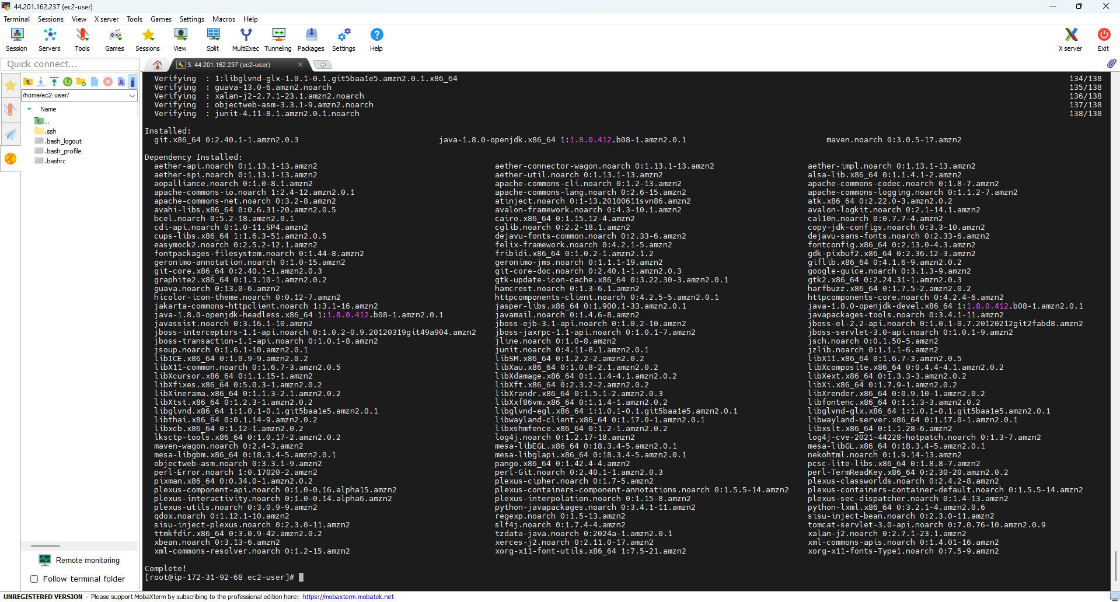

Now by using git clone command to clone the java program from the GitHub link:
- git clone https://github.com/devopsbyraham/jenkins-java-project.git

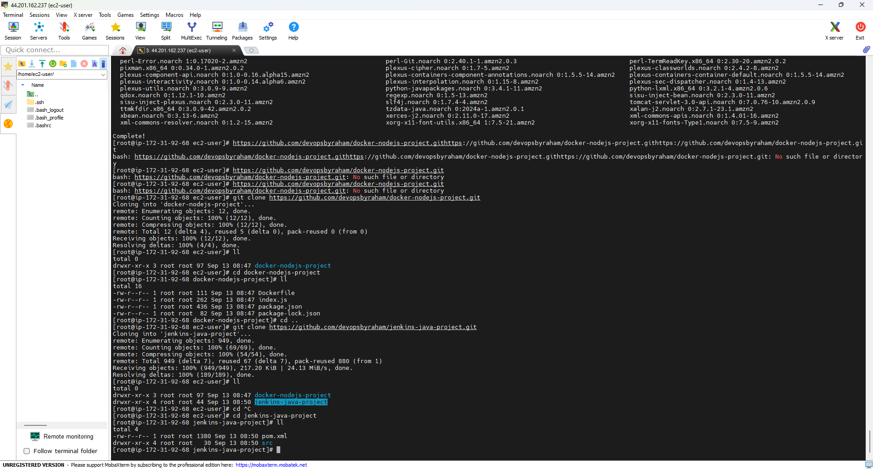


Optional: Install new package called tree by using the command
- yum install tree

Note: it will help us to understand the work of maven command and will make it easy to understand.

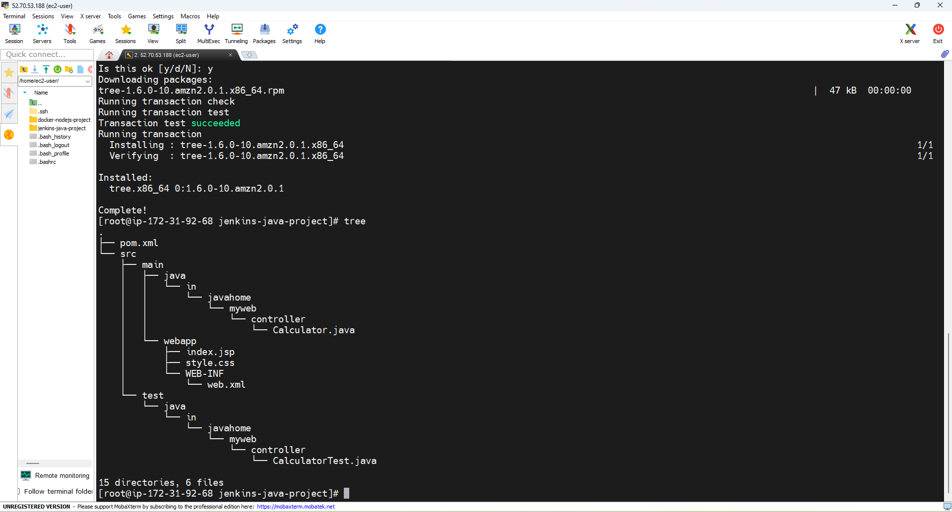

Notes:

The installation of the tree package is generally meant for viewing the

directory and file structures graphically. In relation to Maven, you can

use the tree command to see how many other Maven commands, from mvn compile to mvn clean, change the file structure and contents of our project. Here's how it's done:
- Before executing Maven commands: run tree before running any Maven command to take the initial project structure.
- After executing Maven commands: after performing each Maven command, tree again can be used to see which files or directories were created, deleted, or modified. Everything will be clear and visually perceived in a view how Maven manages the build process and output files.

For example:
- mvn compile: Packs compiled .class files in the target directory.
- mvn test: Runs tests and perhaps generates reports or test-related files.
- mvn package: Puts the compiled code into a jar, both within the target directory.
- mvn install: Installs the packaged .jar file into the local Maven repository.
- mvn clean: Cleans up the target directory, where all build artifacts are erased.
- mvn clean package: Cleanses target directory after repackaging the project.

Using a tree command before and after these Maven commands lets us see exactly where the files were created, exactly what was created, and at just which points in the lifecycle of the project structure changes.

1st Command of Maven (mvn compile):

This command uses to compile the code and covert the code

from .java to .class

The command is:
- mvn compile
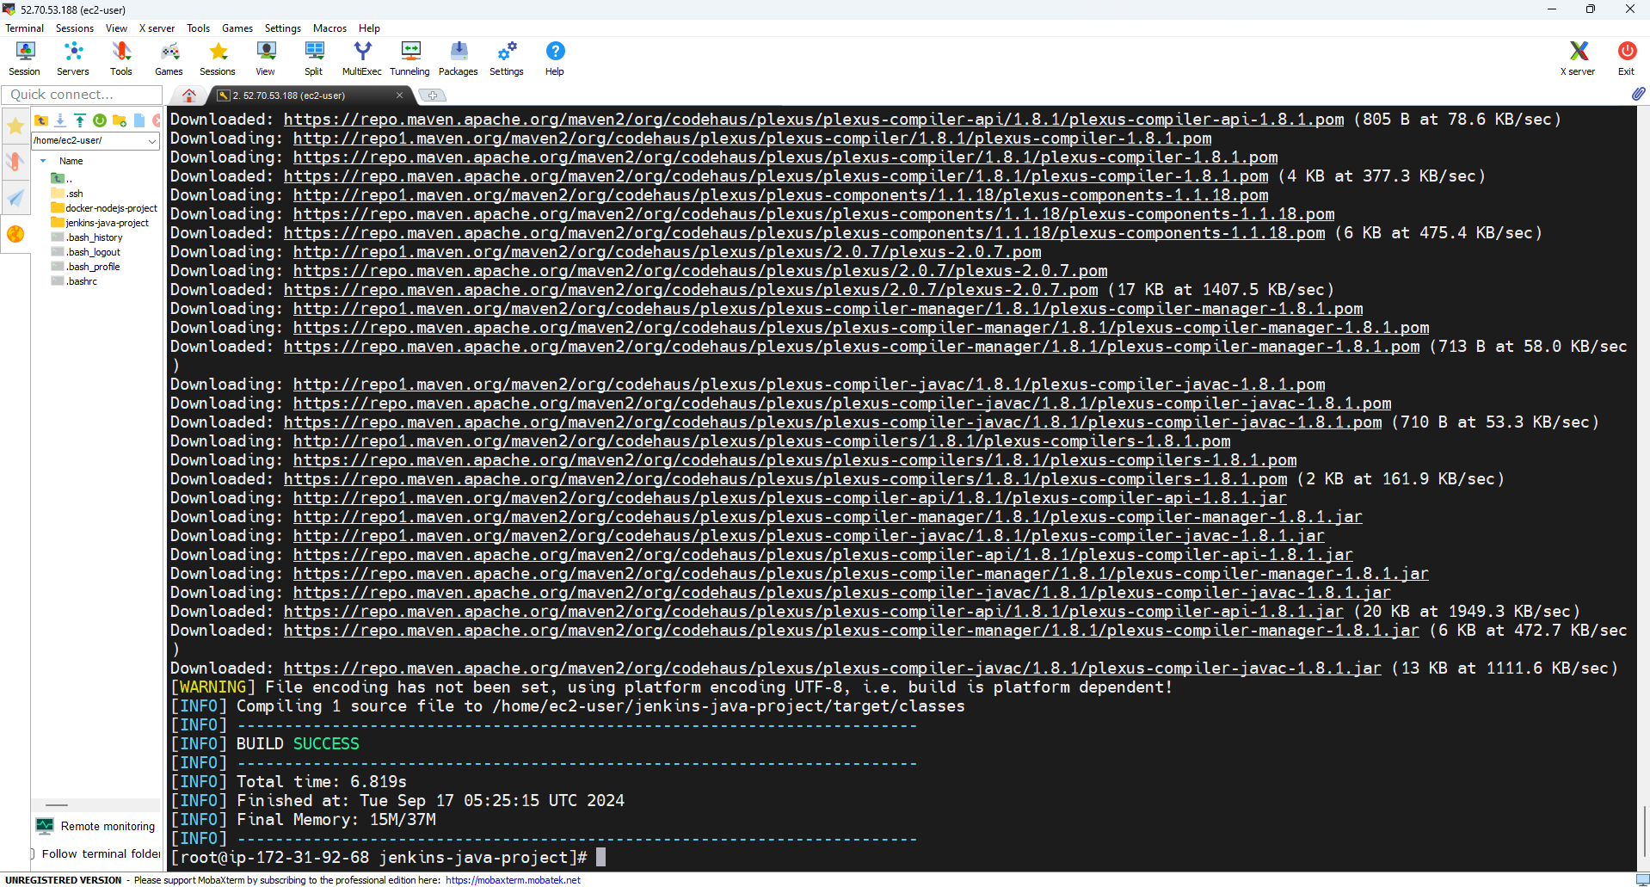

2nd Command of Maven (mvn test):

This command used to check the errors in the given java program.

The command is:
- mvn test

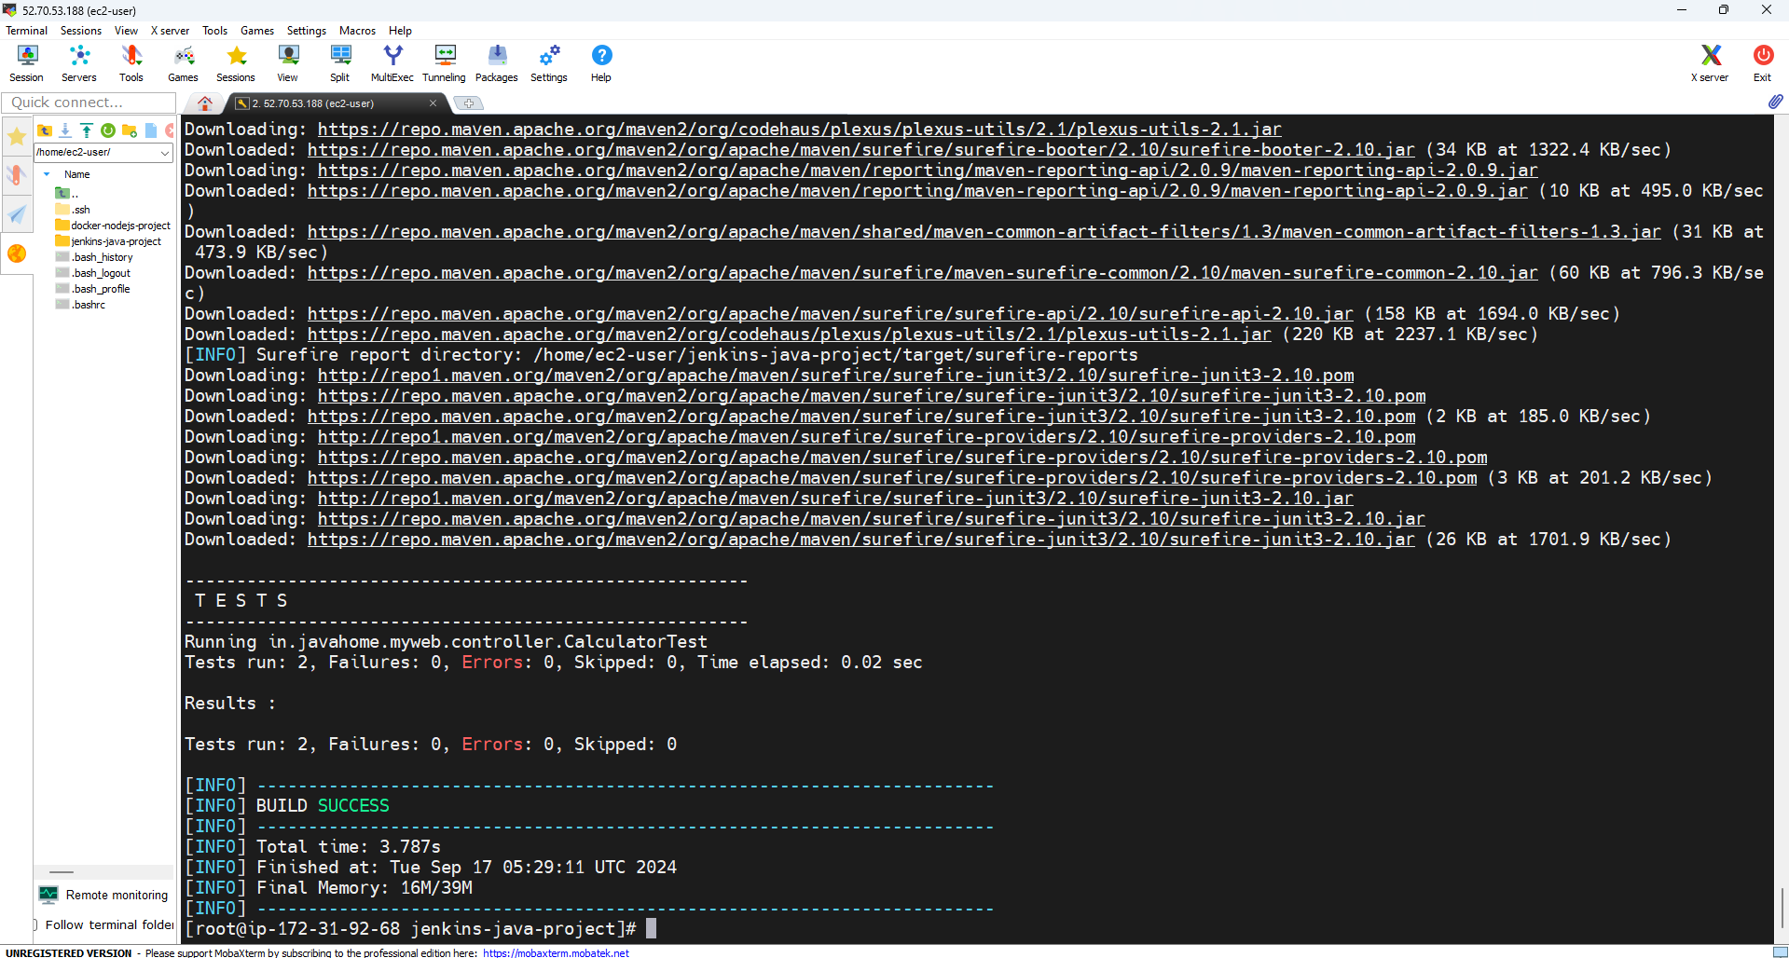

3rd Command of Maven (mvn package):

This command will use to convert .class file to .jar file within the

target directory

The command is:
- mvn package

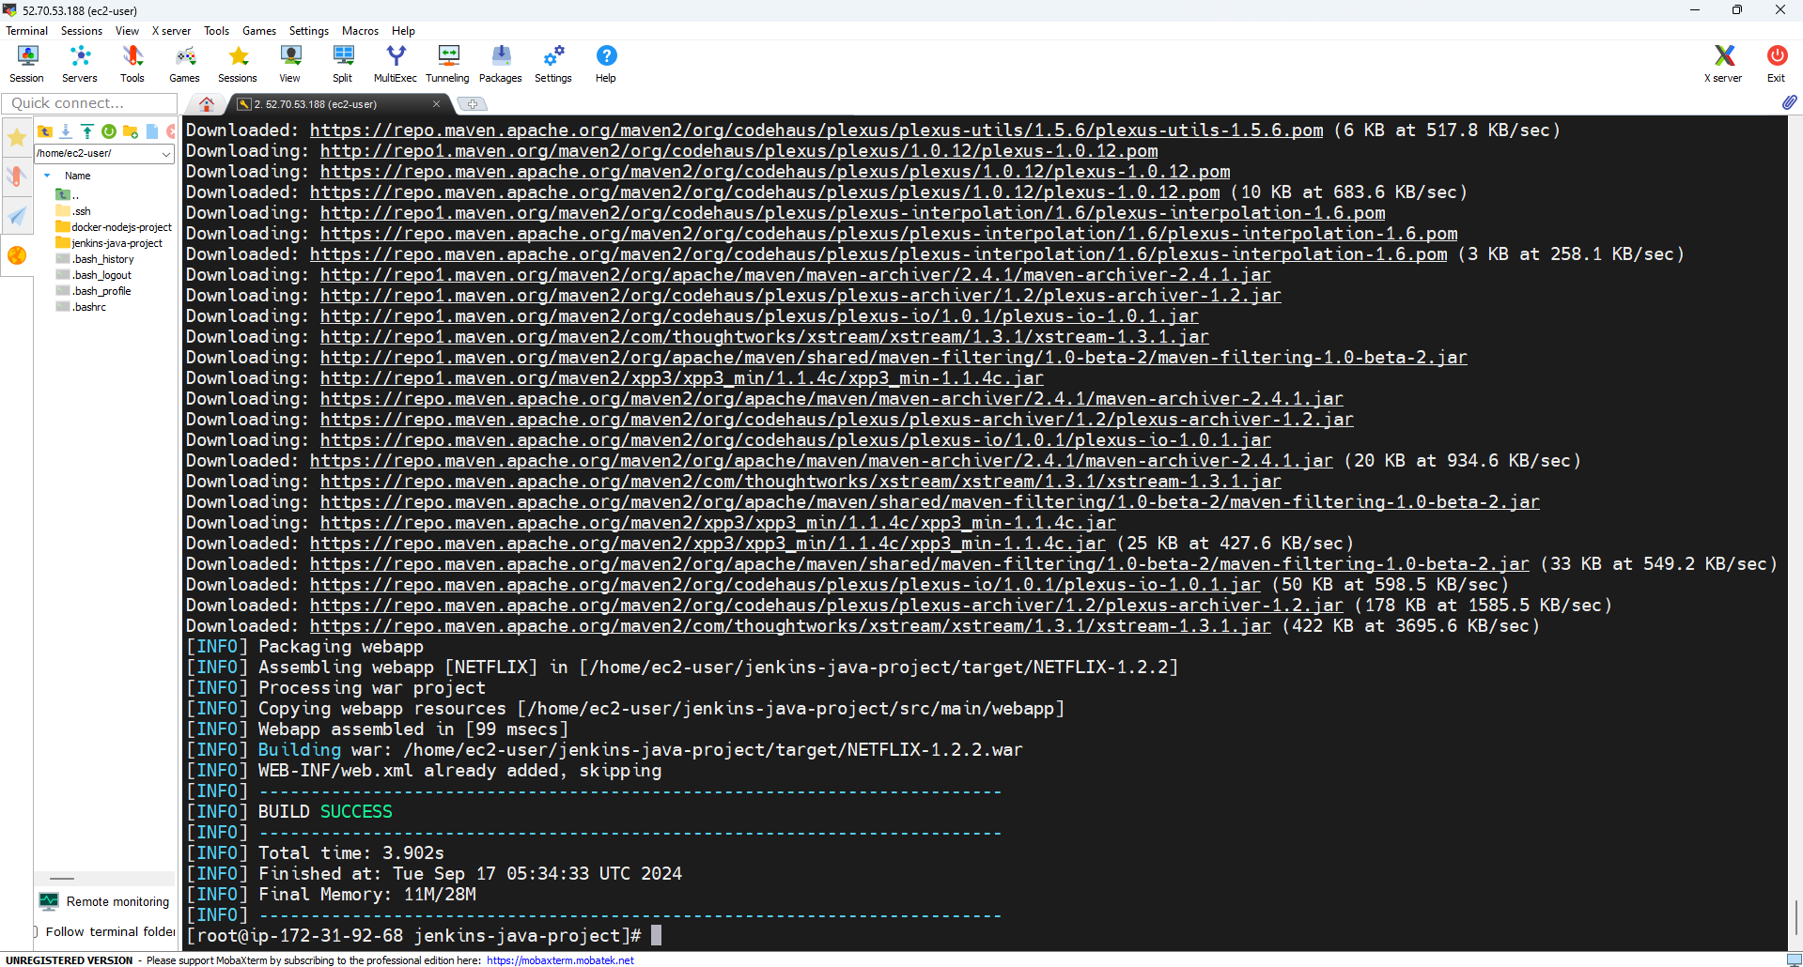

4th Command of Maven (mvn install):

This command will use to convert .class file to .jar file to the

local maven directory

The command is:
- mvn install
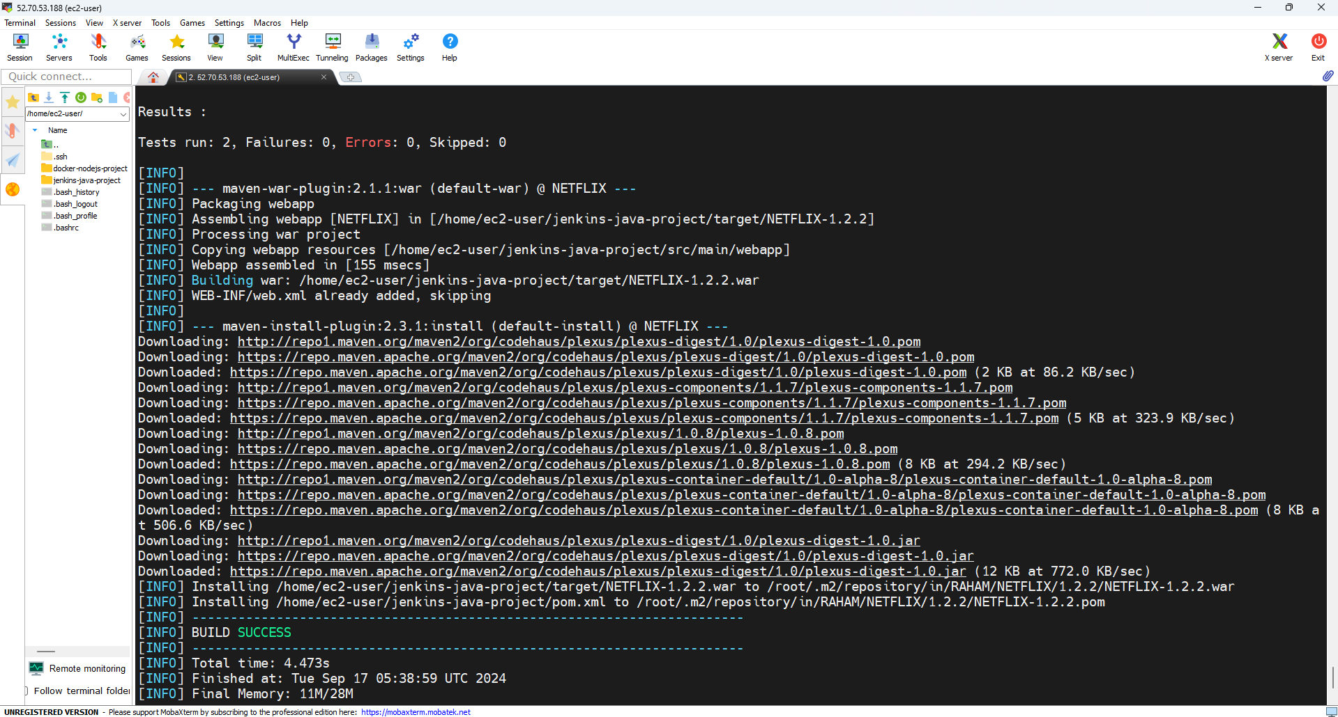


5th Command of Maven (mvn clean package):

The most important Maven command that performs all the steps

(from compile to install) in one go is:
- mvn install

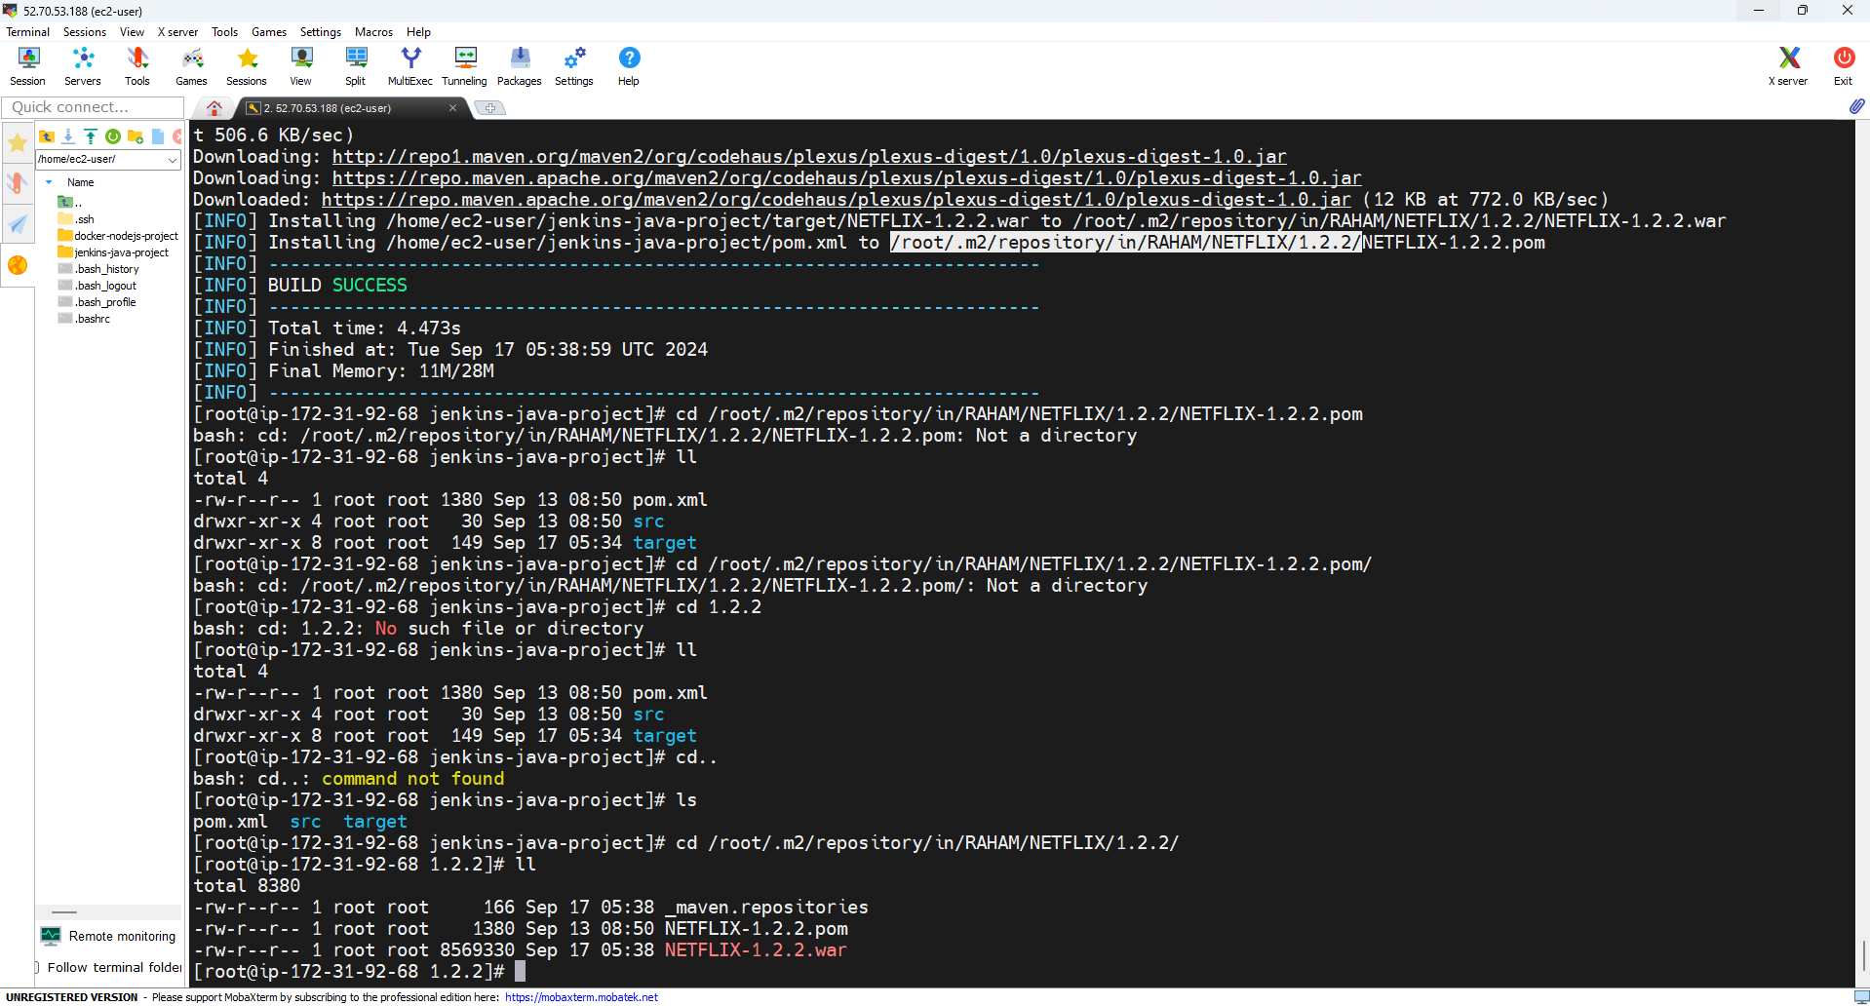

The above command performs the following tasks in sequence:
- Compiles the code (mvn compile)
- Runs the tests (mvn test)
- Packages the code into a .jar or .war file (mvn package)
- Installs the packaged code into the local Maven repository (mvn install)

In summary, mvn install executes all the key steps in one command, making it unnecessary to run mvn compile, mvn test, mvn package, or mvn install separately.

6th Command of Maven (mvn clean):


Delete the target directory, where all build artifacts are erased.

The command is
- mvn clean

Practice and check the output of this command!!

Created By,
Waseem Khan Dawar

